**Candidate: Sachin Yashwant Erande**

**Evolent Project Exercise – Contact management system.**

**Github Source code, documentation and setup location:**

<https://github.com/sacerande/contactapp/tree/master>

**Please Note:**

1. Rest API for contact management application is written using Web API and Consumed using ASP.Net MVC.

Located in Project "ContactApp" under Solution.

1. Database: In Memory collection is used for back end. (when worker process recycles session, collection items removed from memory.) functional aspects can be tested.

*No database restore or configuration required*

1. Project ContactApp.Tests hold end to end unit tests for CRUD using MVC controller. Implemented using MS Test Framework.
2. Install shield setup project to publish site to IIS is added.
3. Exception handling is done using filters and error pages.
4. To run test cases, please set key contactApiBaseAddress in app.config of ContactApp.Tests Project. This key stores host address of the ContactAPI project where it is deployed.
5. Development done using VS 2010

For time being, not used actual database at back end and session management

Do let me know if necessary, so I can add these features.

**Installation Instructions:**

Run setup “Contact Management System.exe” using administrator

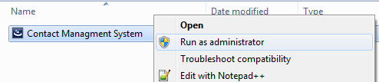

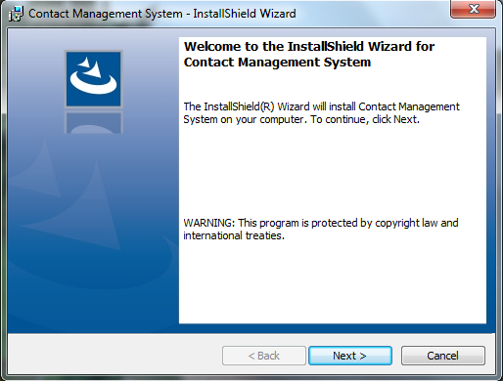

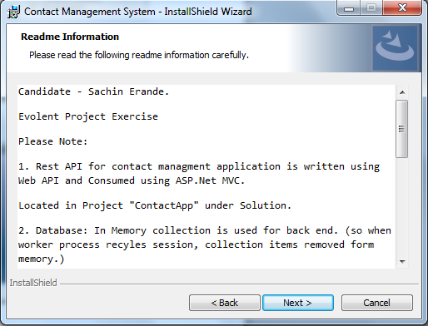

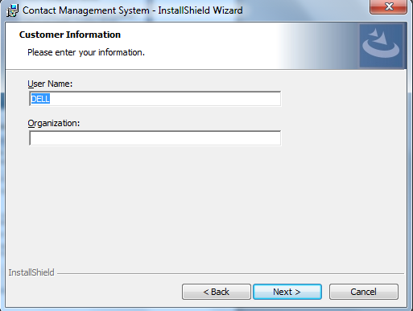

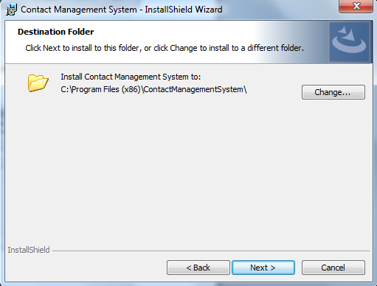

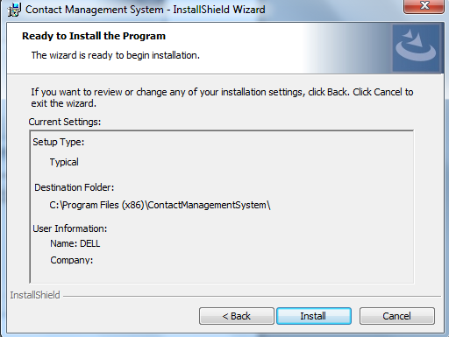

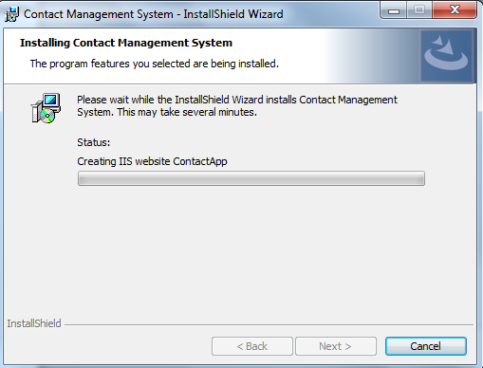

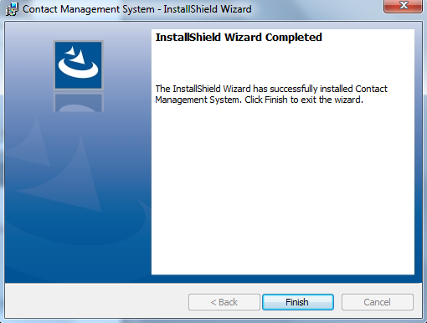

After installation finished,

Notice the website is published under selected location above.

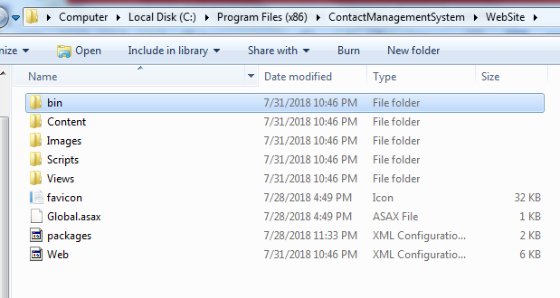

If IIS is installed on machine, site having name “contactApp” will be created and hosted on port 8080.

Click Browse to load the website.

**Screenshot of IIS 7.5 on Windows 7 OS.**

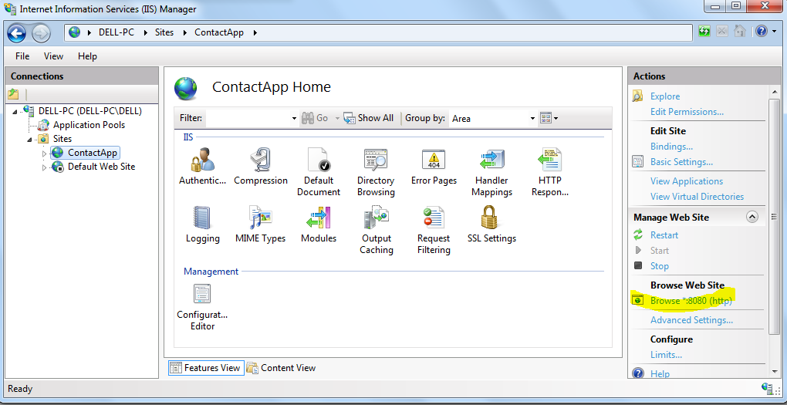

Site loads with some sample set of data already included.

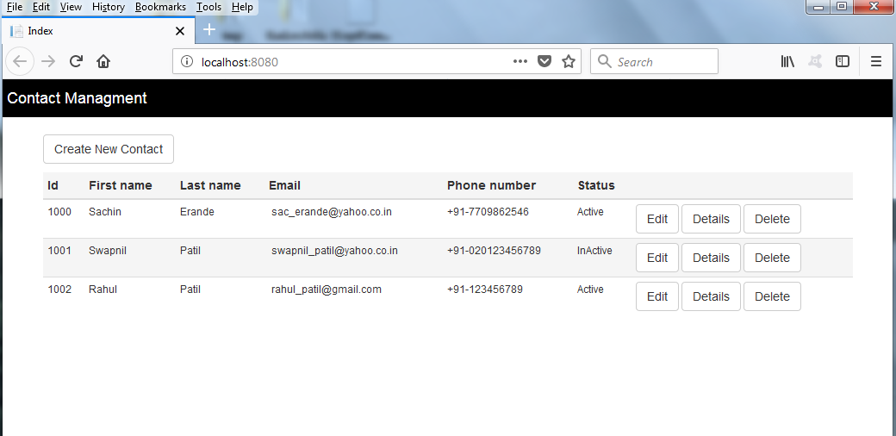

**CRUD Operations:**

1. **Create Contact :**

Click “Create New Contact”

Fill in the information and click “Create Contact”

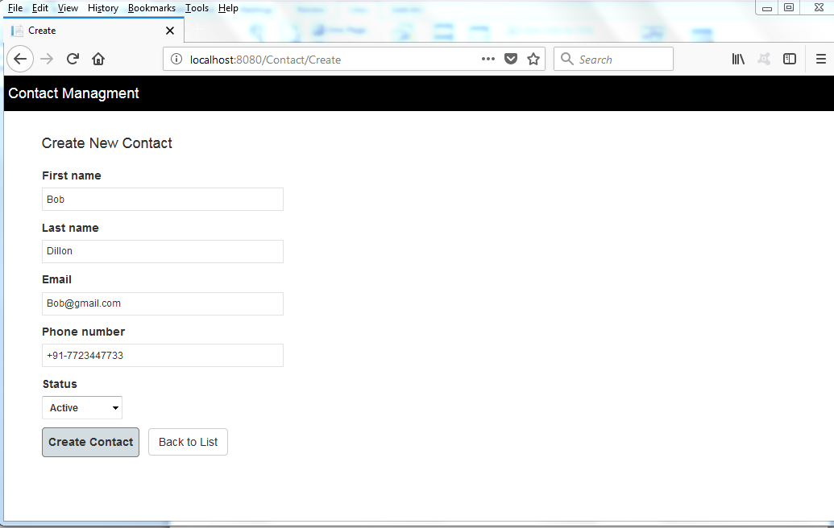

New contact will be added.

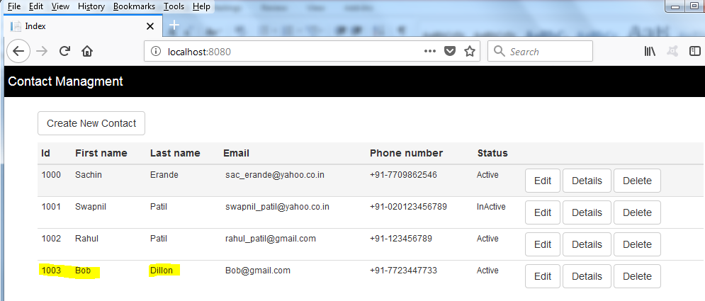

Click Edit button and Edit Contact Page appears.

1. **Edit Contact**

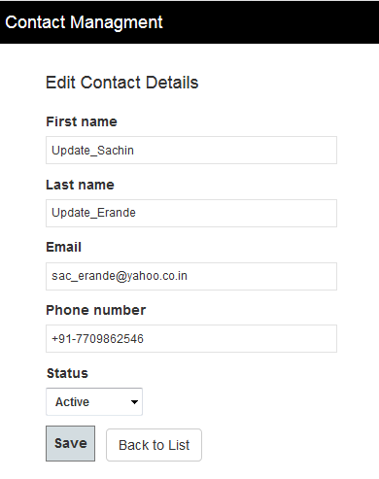

Perform updates and click Save button.

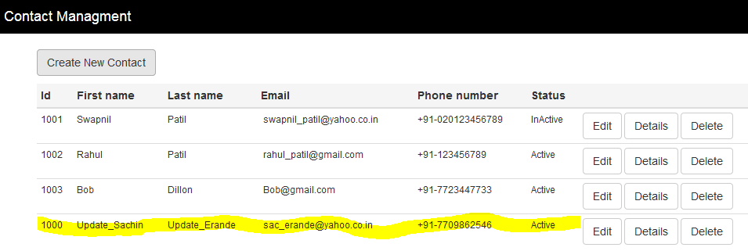

Click Delete to delete contact.

1. **Delete Contact**

Delete confirmation message appears. Click Delete.

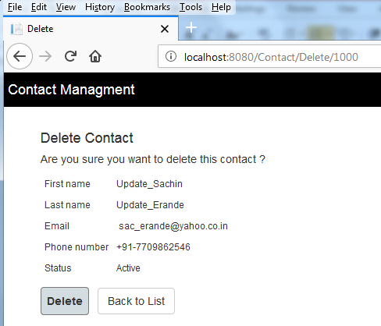

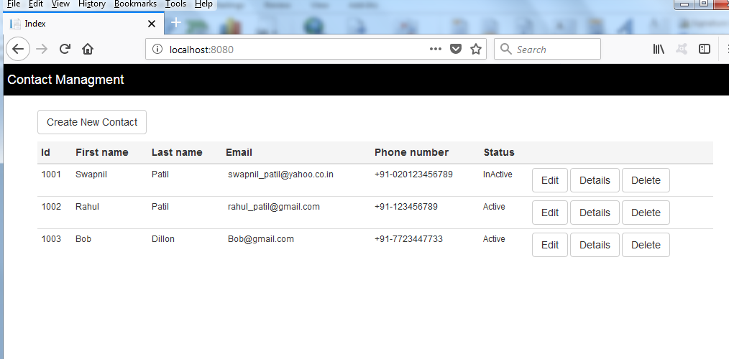

1. **Details**

Click on Details button to see information about contact.

